**2. Manually configure static routes on a router to direct packets to different subnets.**

**Use the ip route command and verify connectivity using ping and traceroute.**

**Steps Followed:**

1. Configured static routes on Router1 and Router2 using the ip route command to enable communication between different subnets.
2. Checked the routing table using show ip route to confirm that the static routes were added correctly.
3. Verified interface status using show ip interface brief to ensure all interfaces were up.
4. Pinged 192.168.2.4 from 192.168.1.3, and it was successful, confirming basic connectivity.
5. Ran traceroute to check the exact path the packets take to reach the destination.

**Setting Up:**

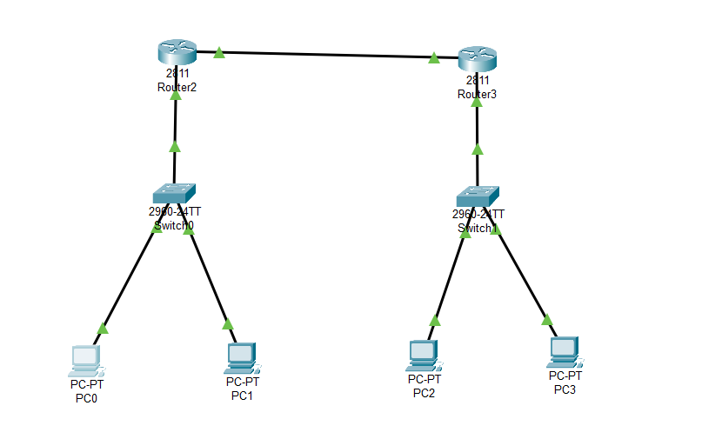

**Router 1 – ip route**

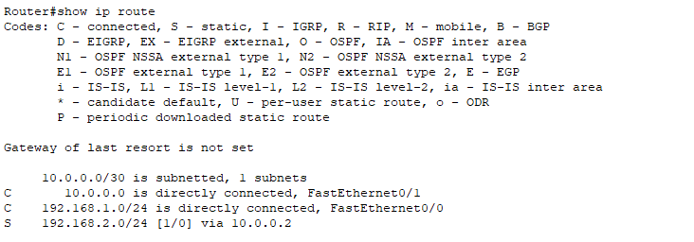

**Router 2 – ip route**

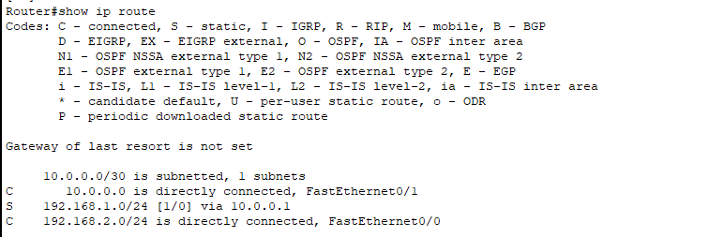

**Testing connectivity using ping:**

**Pinging 192.168.2.4 from 192.168.1.3 - success**

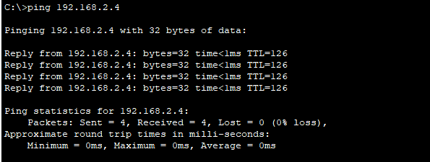

**Traceroute:**

**First hop: 192.168.1.1 –** This is the gateway (likely Router 1).  
**Second hop: 10.0.0.2 –** This is the next router in the path, forwarding the packet to the destination network. **Third hop: 192.168.2.4 –** This is the final destination, meaning the static routes are correctly configured, and the packet reaches the target successfully.

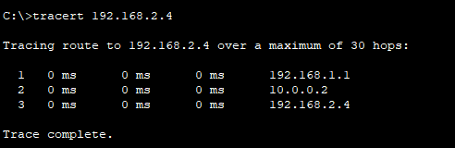

**Observation:**

The successful ping indicates that static routes are properly configured and packet forwarding is working. Traceroute will confirm the hops involved in the packet’s journey.